Project Design
Solution Architecture
Date | 02 October 2026
Student Name | Dhanyaa V S
Project Name | Automated Network Request Management in ServiceNow

1. Multi-Tier Solution Architecture Overview
The Automated Network Request Management solution is implemented using a scalable, multi-tier architecture hosted on the ServiceNow Personal Developer Instance (PDI) cloud platform. The architecture separates user interaction, dynamic catalog presentation, business workflow orchestration, custom data persistence, and platform communications into distinct modular layers.
By leveraging native platform components—including Service Portal (/sp), Catalog UI Policies, Flow Designer, and custom database tables—the architecture eliminates reliance on complex custom script files. This design ensures that every network request submitted by an end user is validated immediately on the client side, written reliably into a dedicated custom table, governed through formal approval hierarchies, and tracked with automated milestone notifications.

System Architecture Diagram

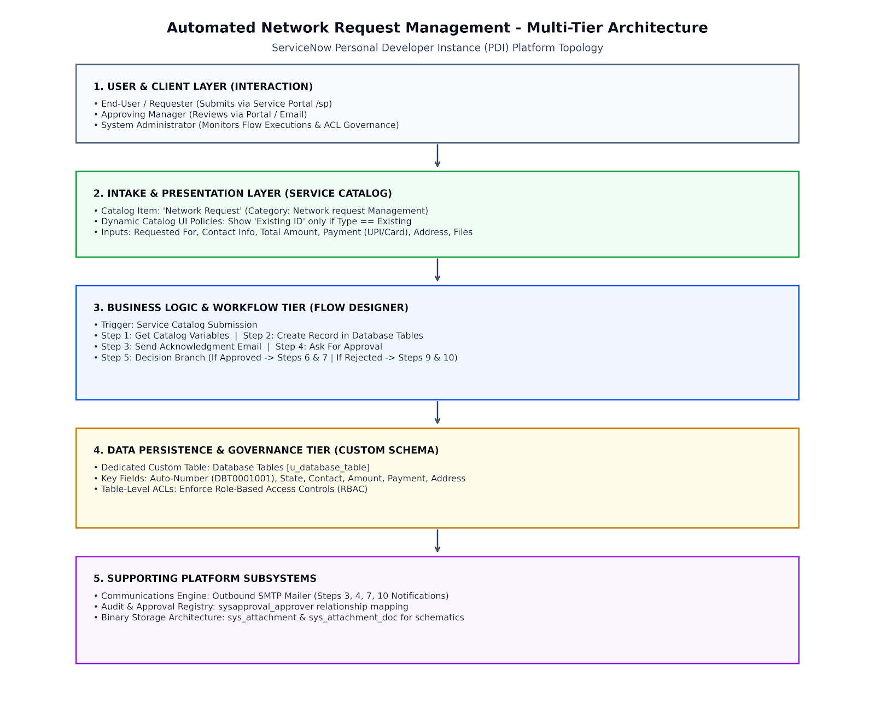
2. Architectural Tiers & Component Specifications
Layer / Tier | ServiceNow Component | Role & Implementation Details
Presentation & Client Tier | Service Portal (/sp) & Service Catalog | • Hosts the Network Request item under the Network request Management category.  • Executes Catalog UI Policies to dynamically display Existing ID only when Type of Connection is Existing.  • Captures Requested For, Opened on behalf of, contact info, connection selection, payment mode (UPI/Card), total fee, and physical installation address.
Business Logic Tier | Flow Designer (10-Step Workflow) | • Trigger: Activated on Service Catalog submission.  • Step 1: Get Catalog Variables from Network Request.  • Step 2: Create Record in Database Tables (u_database_table).  • Step 3: Send Email (instant submission receipt).  • Step 4: Ask For Approval on Database Tables record.  • Step 5: Evaluates approval condition (Approved vs Rejected).  • True Path (Steps 6–7): Update state to Approved and send approval email.  • False Path (Steps 9–10): Update state to Rejected and send rejection notice.
Persistence Tier | Database Tables (u_database_table) | • Custom relational table configured with unique Auto-Numbering (prefix DBT).  • Persists all captured form inputs and tracks the record state lifecycle (Awaiting Approval, Approved, Rejected).  • Integrates with sysapproval_approver for complete auditability and governance.
Communications Tier | Outbound Email Notification Engine (SMTP) | • Integrates with the platform email engine to emit automated milestone messages.  • Dispatches real-time transactional updates containing record numbers, submitted parameters, and approval outcomes to requesters and managers.
Security & Governance Tier | Platform Access Control Lists (ACLs) | • Enforces Role-Based Access Control (RBAC) across table records.  • Restricts requesters to read-only visibility of their own submissions while granting write permissions strictly to administrators and approvers.  • Retains comprehensive audit trails via Flow Execution Details.
Attachment Repository | Attachment Engine (sys_attachment) | • Native binary storage managing uploaded supporting files (network diagrams, site layouts, ID proofs).  • Securely binds binary attachments to the request record with platform-level integrity checks.

3. Solution Design Principles & Quality Attributes

• Zero-Code Maintainability: The end-to-end automation workflow is constructed entirely inside ServiceNow Flow Designer without requiring custom Script Includes or Business Rules. By utilizing standard platform actions, the implementation avoids technical debt, ensures seamless future platform upgrades, and allows administrators to visually troubleshoot execution runs directly via Flow Execution Details.
• Declarative Data Integrity & Validation: Data accuracy is enforced at the earliest point of interaction. Catalog UI Policies dynamically validate mandatory fields (such as Type of Connection, Address, and Total Amount) and conditionally render dependent inputs (such as Existing ID) before any record is created in Database Tables [u_database_table]. This prevents incomplete entries from reaching fulfillers.
• Complete End-to-End Traceability: Every submission automatically generates an Auto-Numbered record key (e.g., DBT0001001) that links catalog inputs directly with the native approval engine (sysapproval_approver). This creates an immutable audit trail showing who requested the connection, who authorized it, and when status transitions occurred.
• Enterprise Architectural Extensibility: The solution’s modular architecture separates form intake from workflow orchestration and database persistence. In future deployment phases, the Flow Designer workflow can be extended via Integration Hub spokes to communicate directly with enterprise network controllers (such as Cisco DNA Center or Ansible) for automated port provisioning without restructuring the intake layer.

